Report
Of
CLOUD COMPUTING INTERNSHIP REPORT
Submitted
To
School of Computer Science and Engineering
IILM University, Greater Noida, U.P.
In partial fulfilment of the requirement of degree of
B.Tech CSE

By
Roll Number of Student: __________
Name of Student: PALASH MALVIYA
Candidate ID: BS/REG/126233
Batch: 2026-27

CANDIDATE'S DECLARATION
I, PALASH MALVIYA, do hereby declare that the internship report titled “Cloud Computing Internship Report” has been completed by me to fulfil the requirement for the award of the degree of Bachelor of Technology in CSE. All the references have been quoted and I have not taken as such any material from any other source. I affirm to you that this report is my own and has not been submitted to any other institute for any degree/diploma requirement and further I shall be solely responsible for any kind of copyright violation in this regard.
Signature: __________________________
Student Name: PALASH MALVIYA
Roll No.: __________________________

ACKNOWLEDGEMENT
I am using this opportunity to express my gratitude to everyone who supported me throughout the Internship Program. I am thankful for their aspiring guidance, invaluably constructive criticism and friendly advice during this work. I am sincerely grateful to them for sharing their truthful and illuminating views on a number of issues related to this work. I express my gratitude to my parents for their blessings.
Signature: __________________________
Student Name: PALASH MALVIYA
Roll No.: __________________________

INTERNSHIP COMPLETION CERTIFICATE
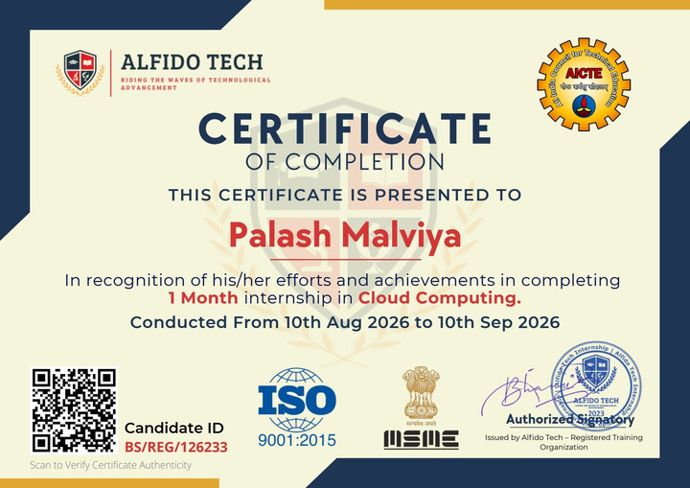
Fig 3.1: Internship Completion Certificate issued by Alfido Tech for the 1-Month Cloud Computing Internship (Candidate ID: BS/REG/126233)

TABLE OF CONTENTS
Chapter No. | Chapter Name | Page Nos.
 | Cover Page | —
1. | Candidate's Declaration | i
2. | Acknowledgement | ii
3. | Internship Completion Certificate | —
4. | Project Description | 1
 | 4.1 Introduction | 1
 | 4.2 Organization Profile | 1
 | 4.3 Problem Statement | 2
 | 4.4 Project Objectives | 2
 | 4.5 Scope of the Project | 2
 | 4.6 Technologies and Tools Used | 3
 | 4.7 System Architecture | 4
 | 4.8 Methodology | 4
 | 4.8.1 Task 1: Deploy a Static Website on AWS S3 | 5
 | 4.8.2 Task 2: Deploy a Virtual Machine & Install Web Server | 16
 | 4.8.3 Task 3: Create a Serverless Function | 26
 | 4.8.4 Task 4: Deploy a Docker Container on Cloud VM | 33
 | 4.9 Expected Outcomes | 36
 | 4.10 Certificates of Completion and Other Communication/Mail Proof | 36
5. | Bibliography / References | 38
Note: Page references are aligned with the final formatted report layout.

4. PROJECT DESCRIPTION
4.1 Introduction
This report presents the work carried out during the Cloud Computing Internship undertaken at Alfido Tech. The internship was designed to provide hands-on, practical exposure to core cloud computing services offered by Amazon Web Services (AWS), moving beyond theoretical concepts into real deployment scenarios. Over the course of the internship, four independent tasks were completed, each targeting a distinct area of cloud infrastructure: static website hosting, virtual machine provisioning and web server configuration, serverless computing, and containerized application deployment.
The tasks were performed using the AWS Free Tier console and covered services including Amazon S3, Amazon EC2, AWS Lambda, Amazon API Gateway, and Docker running on a cloud virtual machine. Each task was executed end-to-end - from resource provisioning and configuration, through deployment, to verification of the final publicly accessible result - and documented with screenshots captured directly from the AWS Management Console and the deployed applications.
4.2 Organization Profile
Organization Name: Alfido Tech
Alfido Tech is a Hyderabad, Telangana (India) based technology training organization that runs structured, task-based internship programs for engineering students, with a focus on emerging domains such as Cloud Computing. The organization is registered under MSME and ISO 9001:2015, and its internship programs are recognized in line with AICTE guidelines. Alfido Tech’s internship model is built around real-world, hands-on tasks rather than purely theoretical modules, supported by curated learning resources, mentor guidance, and an internship coordination team. On successful completion of all assigned tasks, interns are awarded an official Internship Completion Certificate, and high-performing interns may additionally become eligible for a Letter of Recommendation (LOR).
Supervisor / Mentor Name: Akash Dubey
Internship Duration: 10th August 2026 to 10th September 2026
4.3 Problem Statement
Traditional on-premises infrastructure requires significant upfront investment, manual server management, and lacks the elasticity needed to handle variable workloads. Organizations increasingly need to deploy websites, applications, backend logic, and containerized services in a manner that is scalable, cost-effective, and quickly provisioned. The problem addressed through this internship was to gain practical competence in deploying and managing such services on a public cloud platform (AWS), covering the complete spectrum from static content hosting to compute, serverless execution, and containerization, while ensuring that each deployment is configured securely and is publicly verifiable.
4.4 Project Objectives
- To deploy a static website using Amazon S3 with public access configured through bucket policies.
- To provision a virtual machine on Amazon EC2, configure network security, and install and run a web server (Apache2) on it.
- To design and deploy a serverless function using AWS Lambda and expose it publicly through Amazon API Gateway.
- To deploy a containerized application (Nginx) using Docker on a cloud-hosted Ubuntu virtual machine and make it publicly accessible.
- To document each deployment with configuration details, commands used, and verification evidence (screenshots).
4.5 Scope of the Project
The scope of this internship was limited to four self-contained cloud deployment tasks performed on the AWS Free Tier, within the eu-north-1 (Stockholm) AWS region. The work covered storage-based static hosting (S3), compute provisioning (EC2), serverless function execution with API exposure (Lambda + API Gateway), and containerized deployment (Docker on EC2). The scope did not extend to advanced production concerns such as custom domain mapping, HTTPS/TLS certificates, auto-scaling, load balancing, CI/CD pipelines, or infrastructure-as-code automation; these represent natural extensions for future work.

4.6 Technologies and Tools Used
Category | Technologies / Tools
Cloud Platform | Amazon Web Services (AWS)
Storage / Hosting | Amazon S3 (Static Website Hosting)
Compute | Amazon EC2, Ubuntu Server
Web Server | Apache2
Serverless Computing | AWS Lambda (Python 3.12)
API Management | Amazon API Gateway (REST API)
Containerization | Docker, Nginx
Languages | HTML, CSS, JavaScript, Python
Operating System | Ubuntu Server (24.04 LTS)

4.7 System Architecture
This section presents the architecture of each of the four deployments, showing the flow of a client request through to the deployed resource on AWS.
Task 1 - Static Website on Amazon S3
User → Internet → Amazon S3 (Static Website)
Task 2 - Virtual Machine with Web Server
User → Internet → AWS EC2 (Ubuntu) → Apache2 → Webpage
Task 3 - Serverless Function
Client → API Gateway → AWS Lambda (Python) → JSON Response
Task 4 - Docker Container on Cloud VM
User → Internet → AWS EC2 (Ubuntu) → Docker → Nginx Container → Webpage
4.8 Methodology
The methodology adopted for the internship followed a consistent, task-by-task approach: provisioning the required AWS resource, applying the necessary security/network configuration, installing or deploying the target software, verifying functionality through the AWS console, and finally validating public accessibility through a browser. Each of the four tasks is detailed below.
4.8.1 Task 1: Deploy a Static Website on AWS S3
Objective: To deploy a static website using Amazon S3.
Tools Used: AWS S3, HTML, CSS, JavaScript.
Bucket Name: task1-alfido-static-website
Website URL: http://task1-alfido-static-website.s3-website.eu-north-1.amazonaws.com/
Procedure:
- Created an Amazon S3 bucket named task1-alfido-static-website.
- Configured the bucket for static website hosting.
- Disabled Block Public Access to allow public access to the website.
- Uploaded the website files, including index.html and the required CSS/JavaScript files.
- Configured an S3 bucket policy to allow public s3:GetObject access.
- Set index.html as the index document for the website.
- Obtained the S3 static website endpoint from the bucket Properties section.
- Opened the endpoint in a web browser and verified that the website was successfully deployed and accessible publicly.
S3 Bucket Policy:
{
"Version": "2012-10-17",
"Statement": [
{
"Sid": "PublicReadGetObject",
"Effect": "Allow",
"Principal": "*",
"Action": "s3:GetObject",
"Resource": "arn:aws:s3:::task1-alfido-static-website/*"
}
]
}
Screenshots / Evidence:
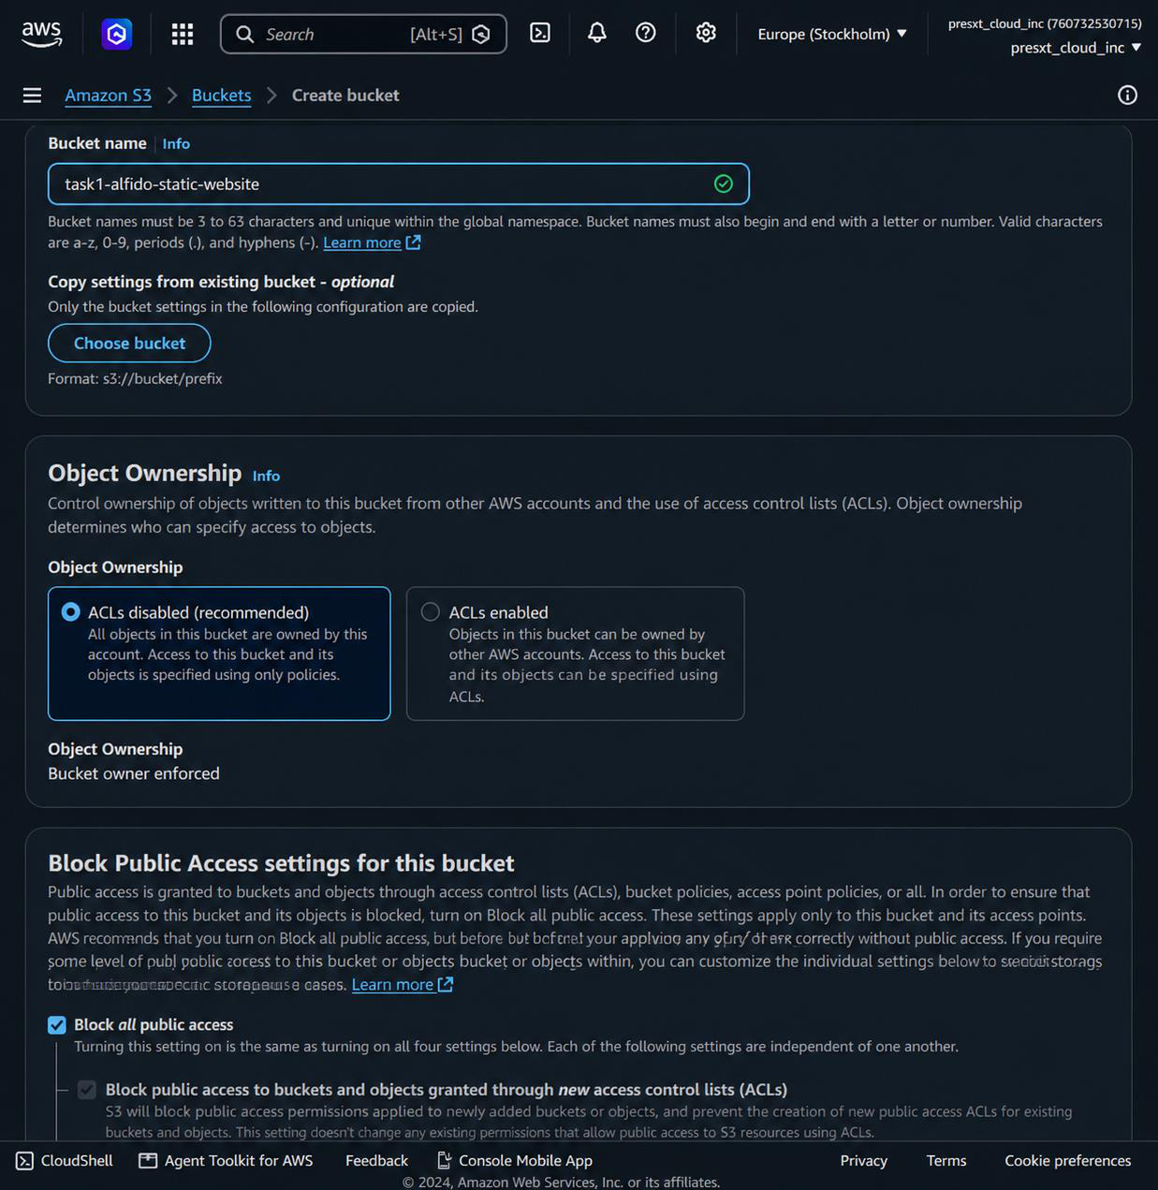
Fig 4.8.1(a): Creating the S3 bucket “task1-alfido-static-website”

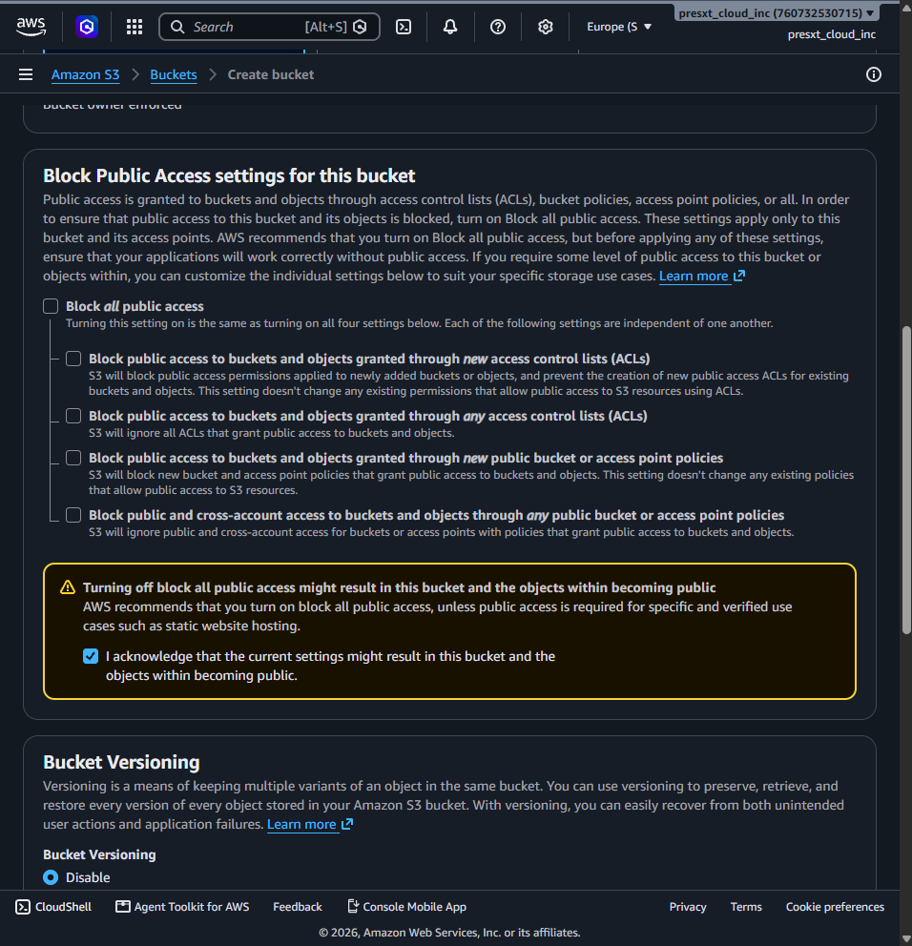
Fig 4.8.1(b): Disabling Block Public Access for the bucket

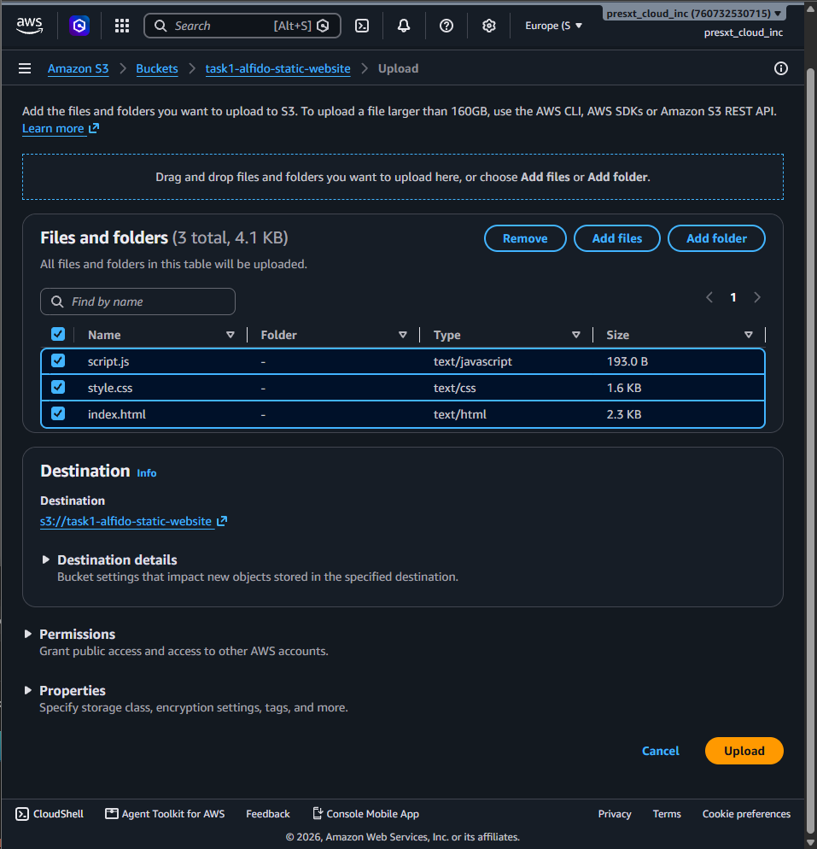
Fig 4.8.1(c): Uploading website files (index.html, style.css, script.js) to the bucket

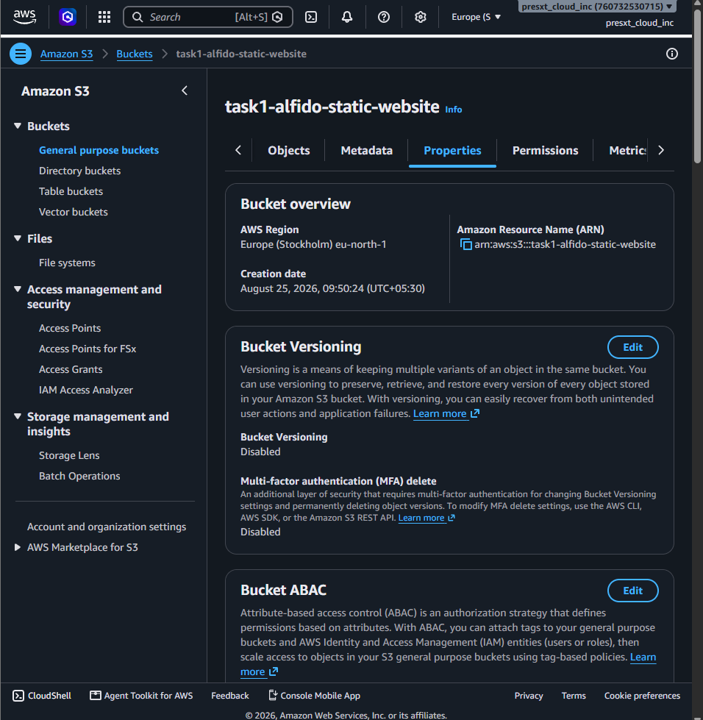
Fig 4.8.1(d): Bucket overview showing region and configuration details

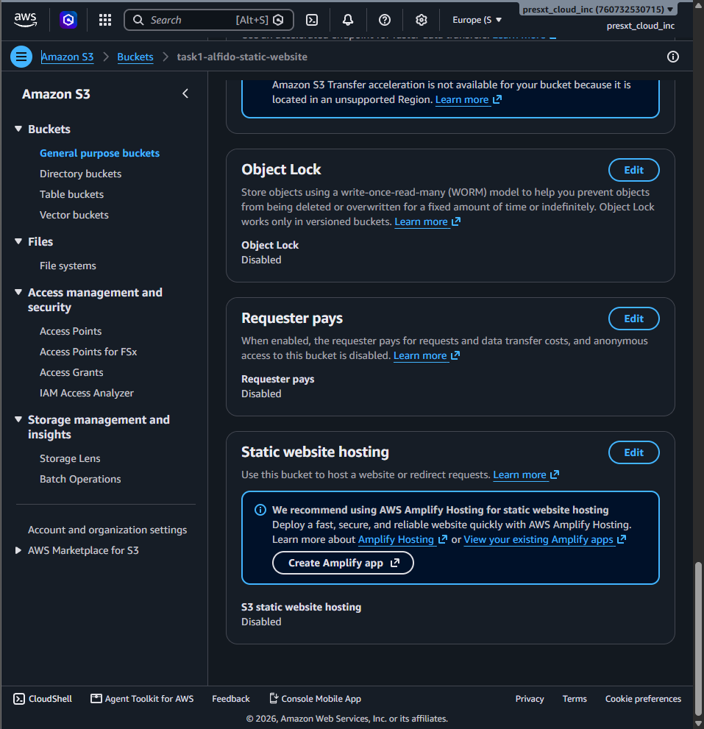
Fig 4.8.1(e): Static website hosting section before enabling hosting

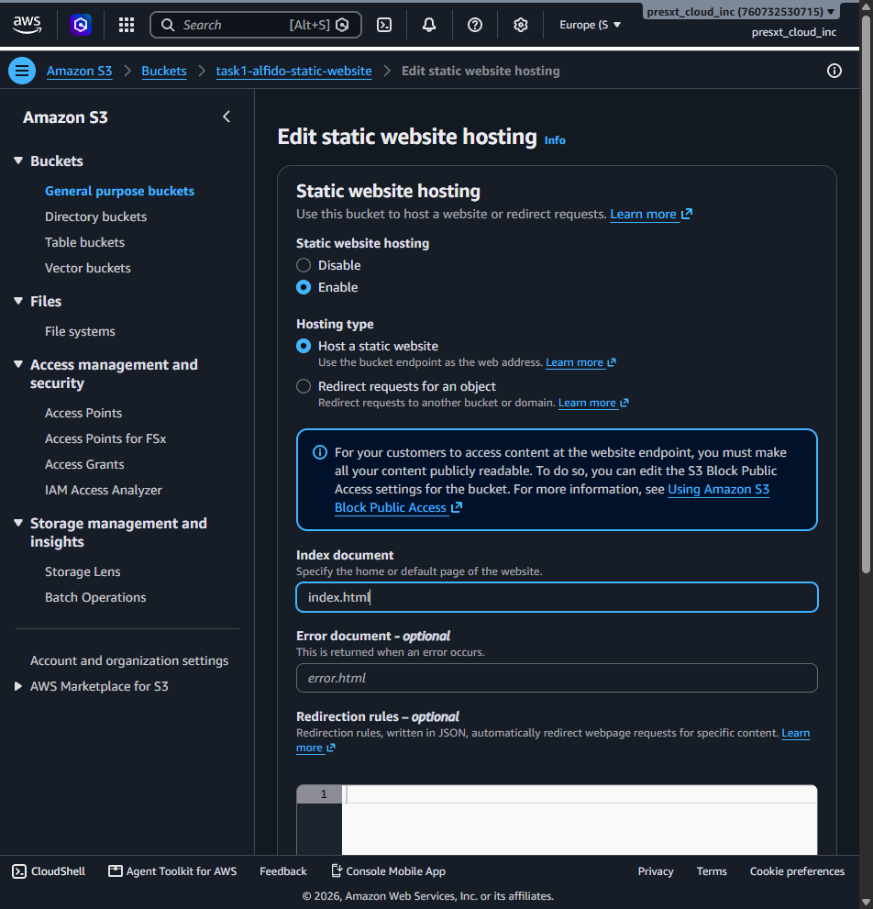
Fig 4.8.1(f): Enabling static website hosting with index document set to index.html

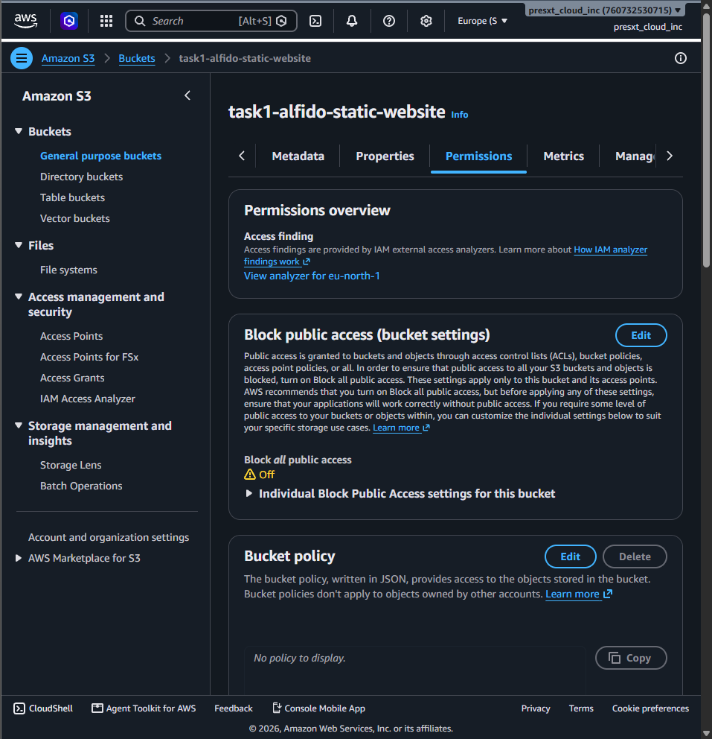
Fig 4.8.1(g): Bucket permissions overview with Block Public Access turned off

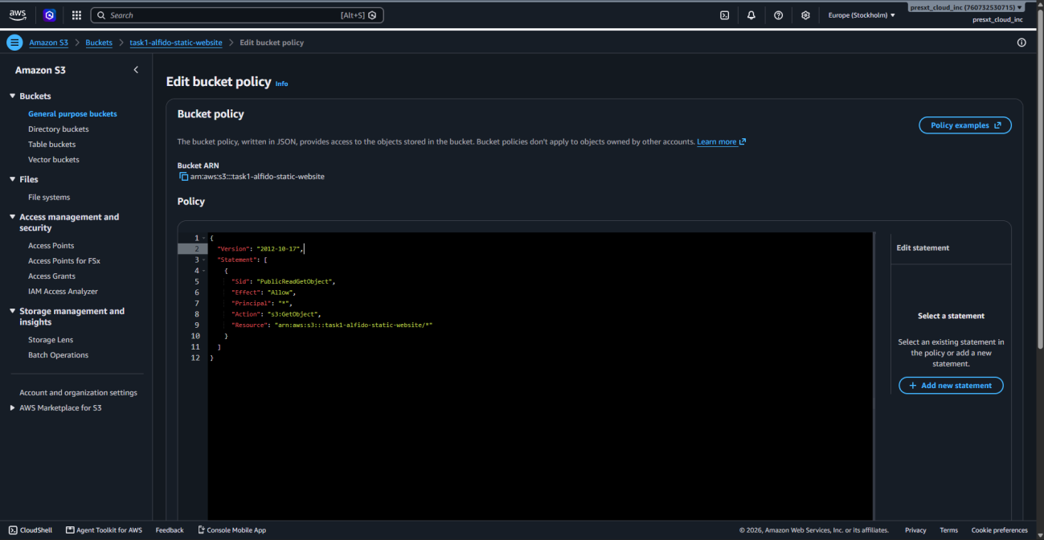
Fig 4.8.1(h): S3 bucket policy granting public s3:GetObject access

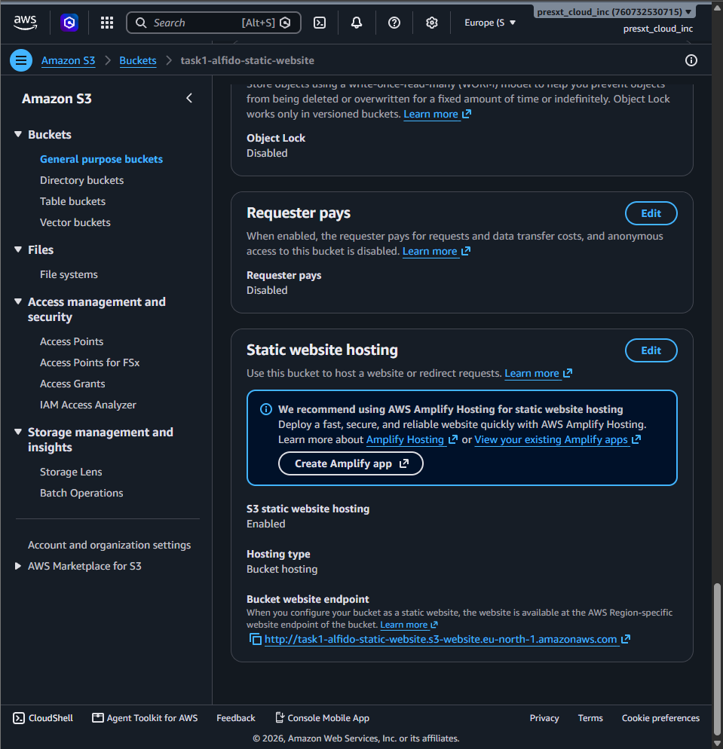
Fig 4.8.1(i): Static website hosting enabled, showing the bucket website endpoint

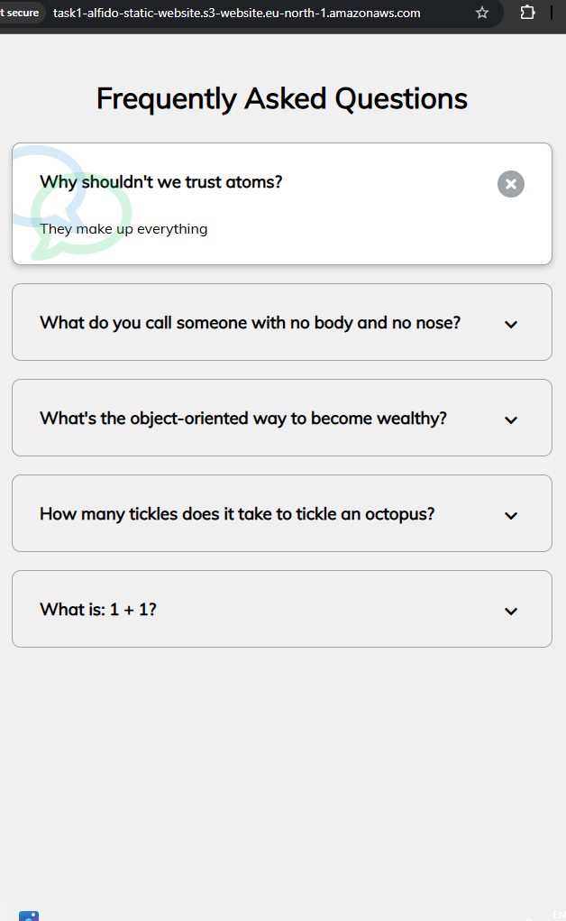
Fig 4.8.1(j): Live static website accessed publicly via the S3 website endpoint

Result: The static website was successfully deployed and accessed through the public S3 website endpoint.
4.8.2 Task 2: Deploy a Virtual Machine & Install Web Server
Objective: To create an Ubuntu virtual machine on AWS EC2, configure port 80, install the Apache web server, and host a custom “Hello from Cloud VM” webpage.
Tools Used: AWS EC2, Ubuntu Server, Apache2.
Cloud Provider: AWS EC2
Operating System: Ubuntu Server
Instance Name: task2-alfido-cloud-vm
Public IPv4: 13.60.163.6
Web Server: Apache2
Port: 80
Procedure:
- Created an Ubuntu Server virtual machine using AWS EC2.
- Configured the security group to allow HTTP traffic on port 80 (and SSH on port 22).
- Connected to the VM using EC2 Instance Connect.
- Updated the Ubuntu package repository.
- Installed the Apache2 web server.
- Started and enabled the Apache service.
- Created a custom index.html page displaying “Hello from Cloud VM”.
- Accessed the webpage using the VM public IPv4 address.
Commands Used:
sudo apt update
sudo apt install apache2 -y
sudo systemctl enable --now apache2
sudo systemctl status apache2
echo '<h1>Hello from Cloud VM</h1><p>Alfido Tech Internship - Task 2</p>' | sudo tee /var/www/html/index.html
Screenshots / Evidence:
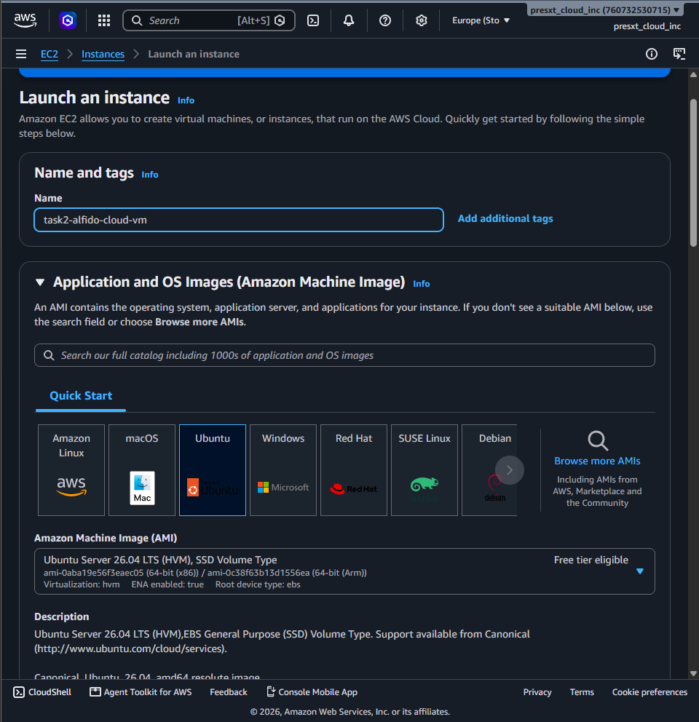
Fig 4.8.2(a): Launching an EC2 instance named “task2-alfido-cloud-vm” with Ubuntu Server AMI

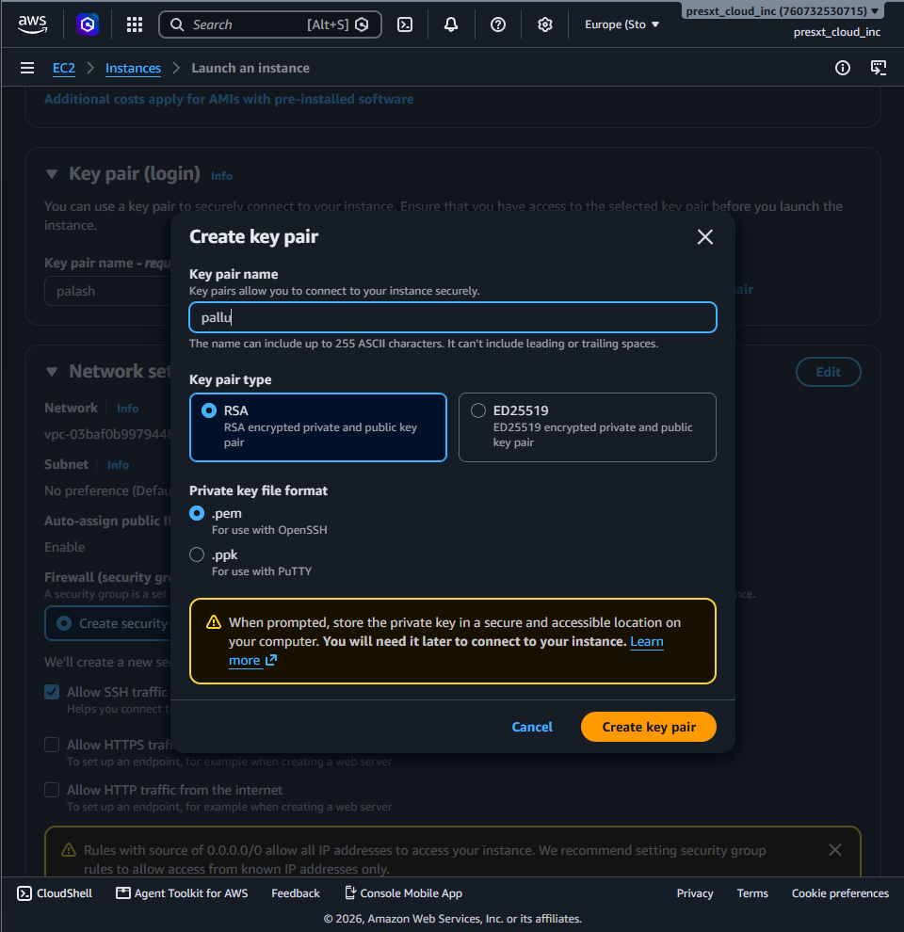
Fig 4.8.2(b): Creating a key pair for secure SSH access to the instance

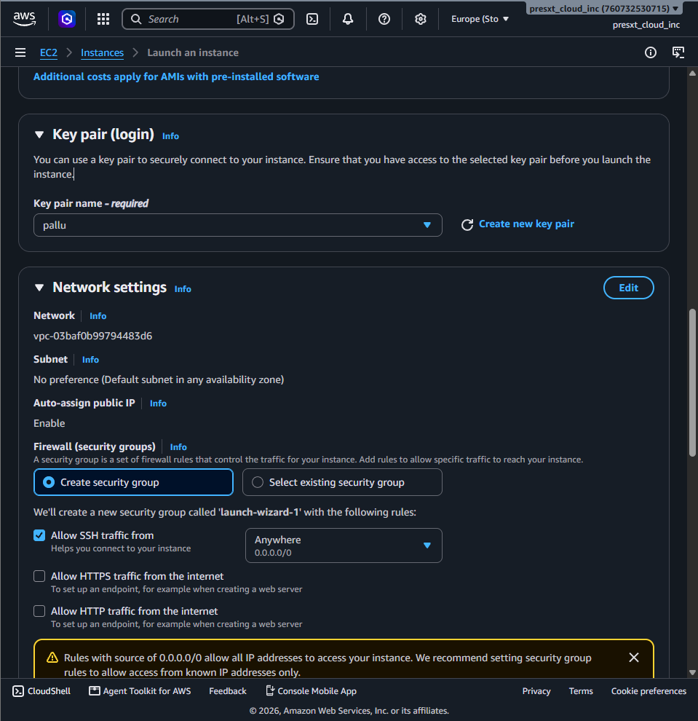
Fig 4.8.2(c): Reviewing key pair and network settings before launch

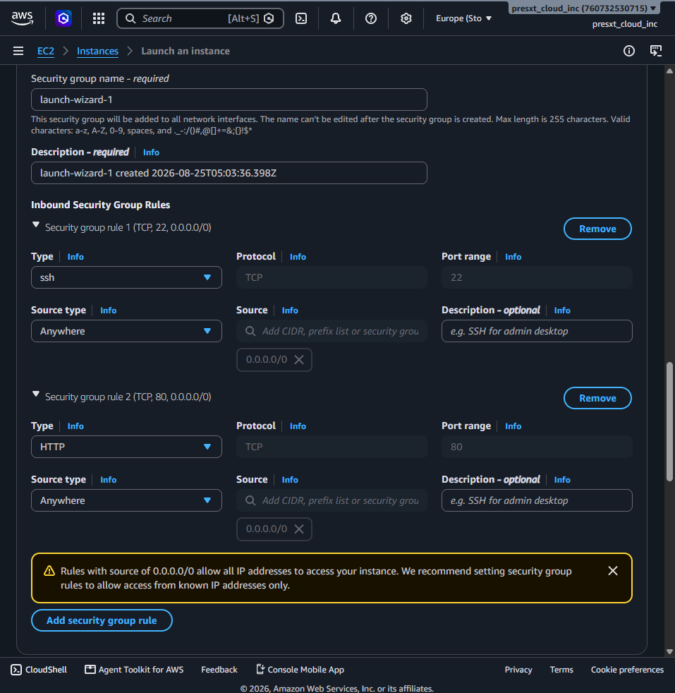
Fig 4.8.2(d): Configuring the security group to allow SSH (port 22) and HTTP (port 80) traffic

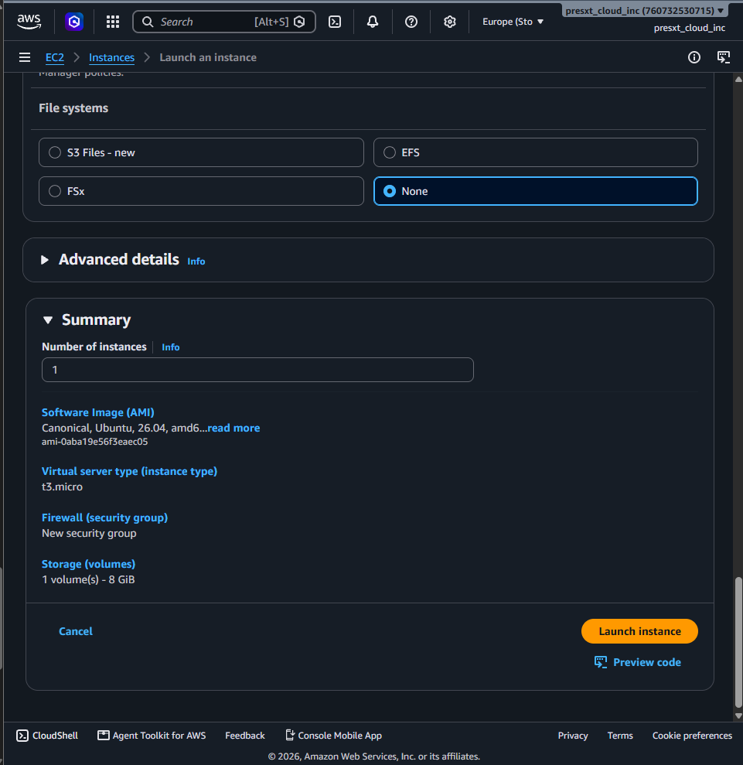
Fig 4.8.2(e): Instance launch summary (AMI, instance type, security group, storage)

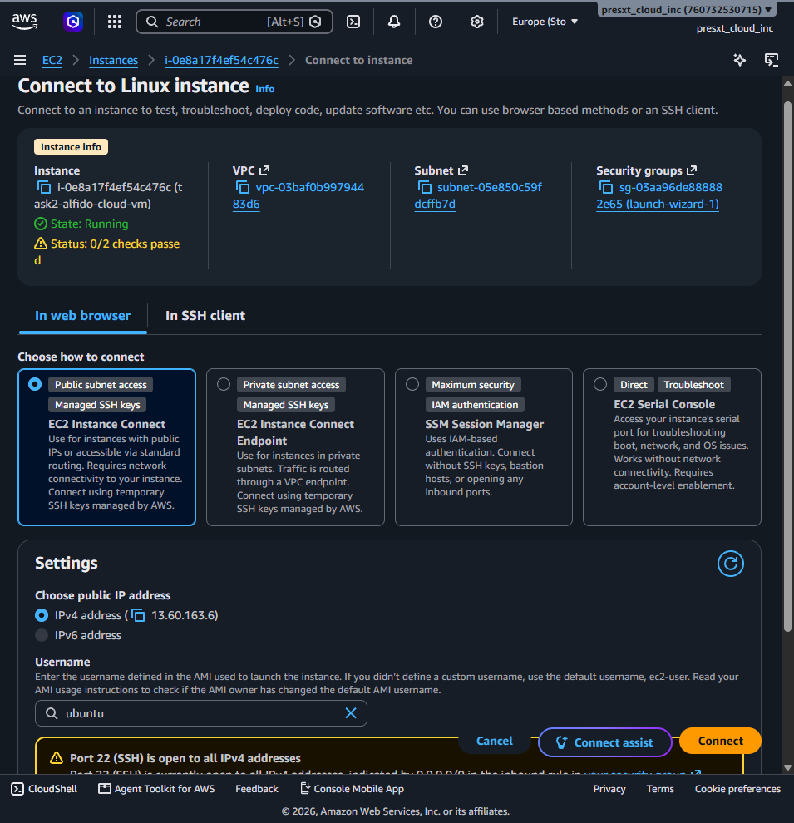
Fig 4.8.2(f): Connecting to the instance using EC2 Instance Connect

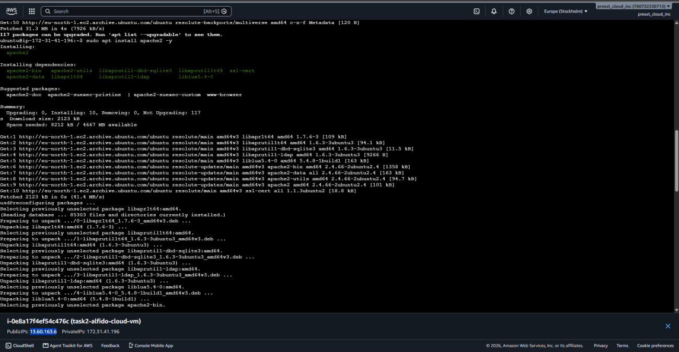
Fig 4.8.2(g): Terminal output of package update and Apache2 installation

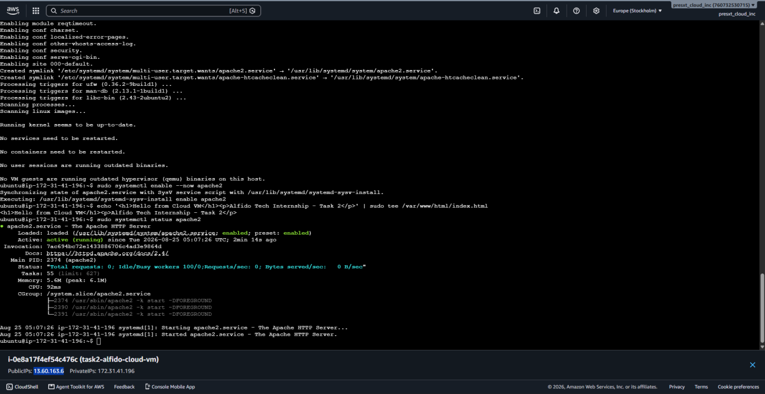
Fig 4.8.2(h): Enabling and starting the Apache2 service, and verifying its running status

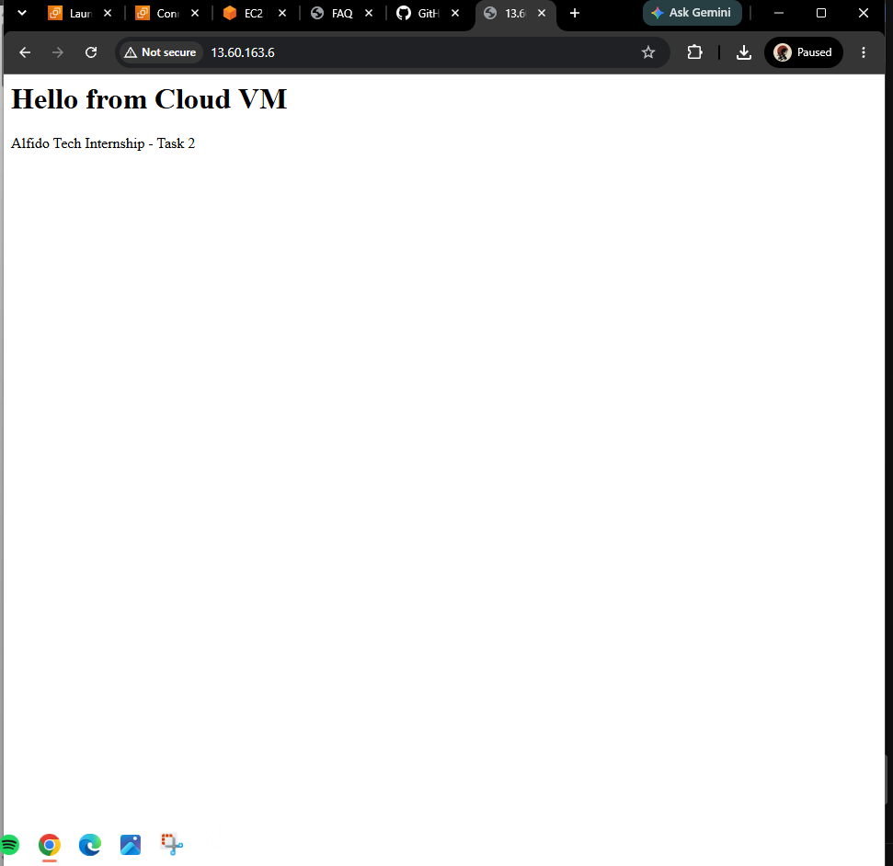
Fig 4.8.2(i): Custom “Hello from Cloud VM” webpage accessed via the instance public IPv4 address

Live Page URL: http://13.60.163.6
Result: The Ubuntu cloud VM was successfully deployed, the Apache web server was installed and configured, and the custom webpage was successfully accessed through the VM public IP address.
4.8.3 Task 3: Create a Serverless Function
Objective: To create a simple serverless function that returns a JSON output.
Tools Used: AWS Lambda, Python, Amazon API Gateway.
Function Name: task3-alfido-serverless
Endpoint URL: https://5vf3sv561b.execute-api.eu-north-1.amazonaws.com/default/task3-alfido-serverless
Procedure:
- Created an AWS Lambda function using Python.
- Configured the Lambda function to return a JSON response.
- Tested the function using the AWS Lambda cloud console.
- Verified the successful execution and JSON output.
- Created an API Gateway trigger for the Lambda function.
- Configured the API Gateway endpoint for public (open) access.
- Deployed the function and obtained the public API endpoint URL.
- Opened the endpoint in a browser and verified that it returned JSON output.
Lambda Function Code:
import json
def lambda_handler(event, context):
return {
"statusCode": 200,
"headers": {
"Content-Type": "application/json"
},
"body": json.dumps({
"message": "Hello from Alfido Tech",
"task": "Task 3",
"status": "success"
})
}
Screenshots / Evidence:
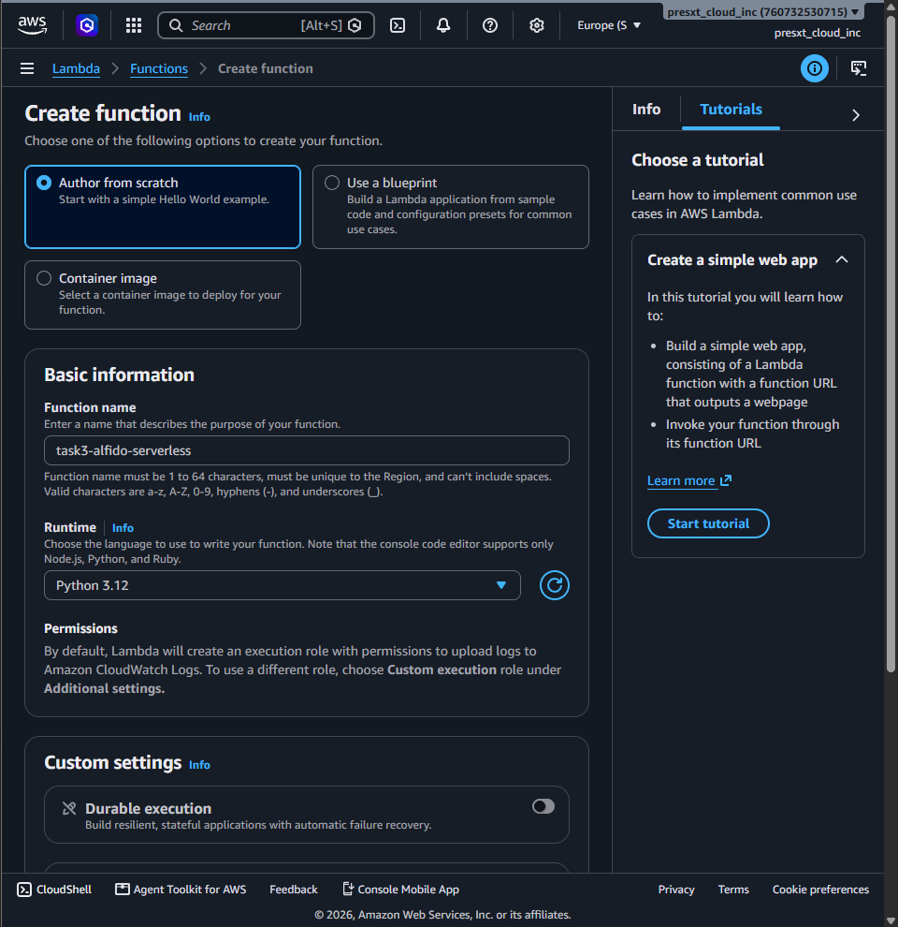
Fig 4.8.3(a): Creating the Lambda function “task3-alfido-serverless” using the Python 3.12 runtime

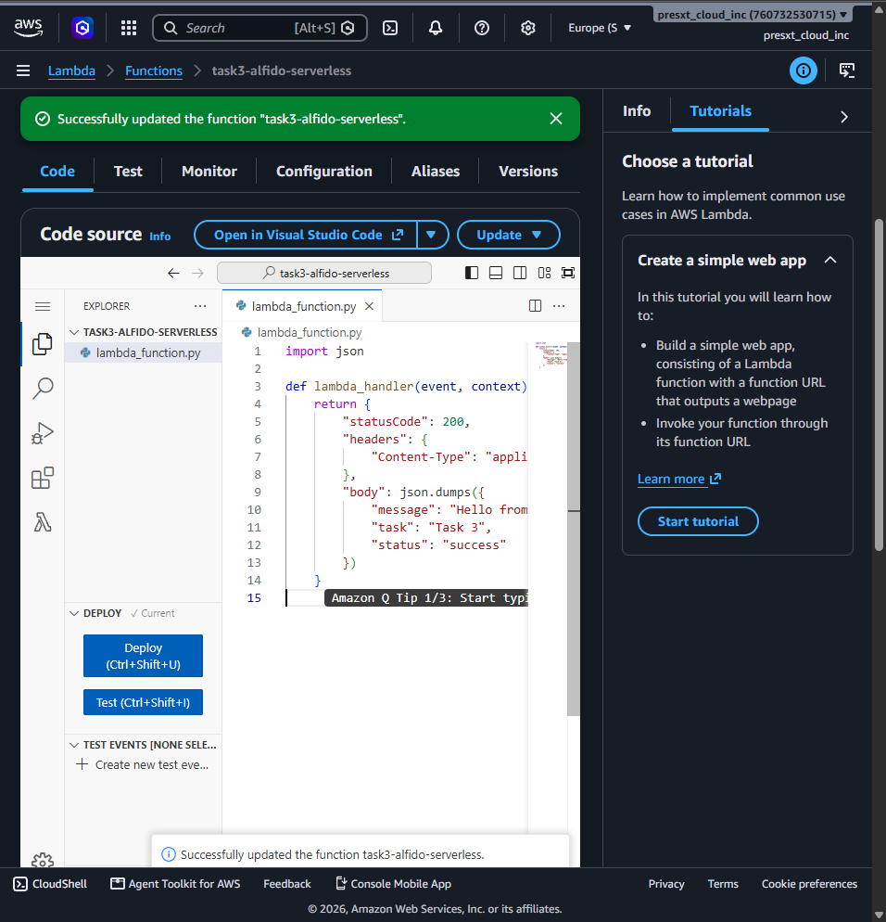
Fig 4.8.3(b): Lambda function code (lambda_function.py) after successful deployment

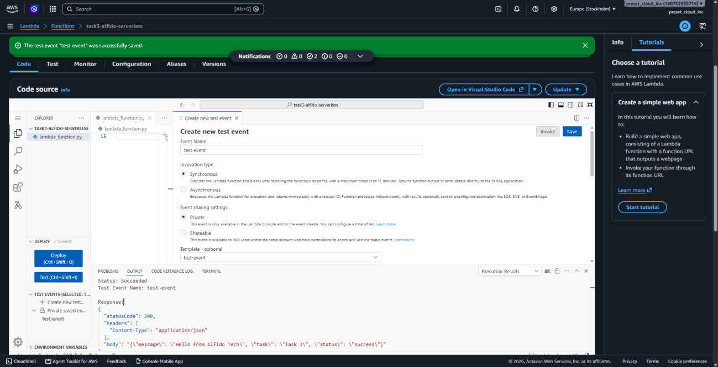
Fig 4.8.3(c): Creating and invoking a test event, with a successful JSON execution result

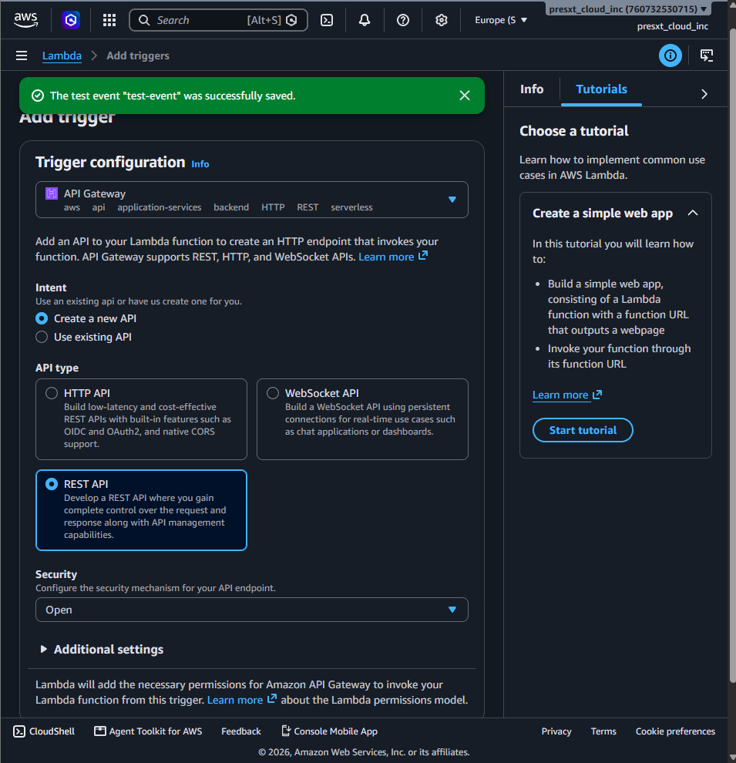
Fig 4.8.3(d): Configuring an API Gateway (REST API) trigger for the Lambda function

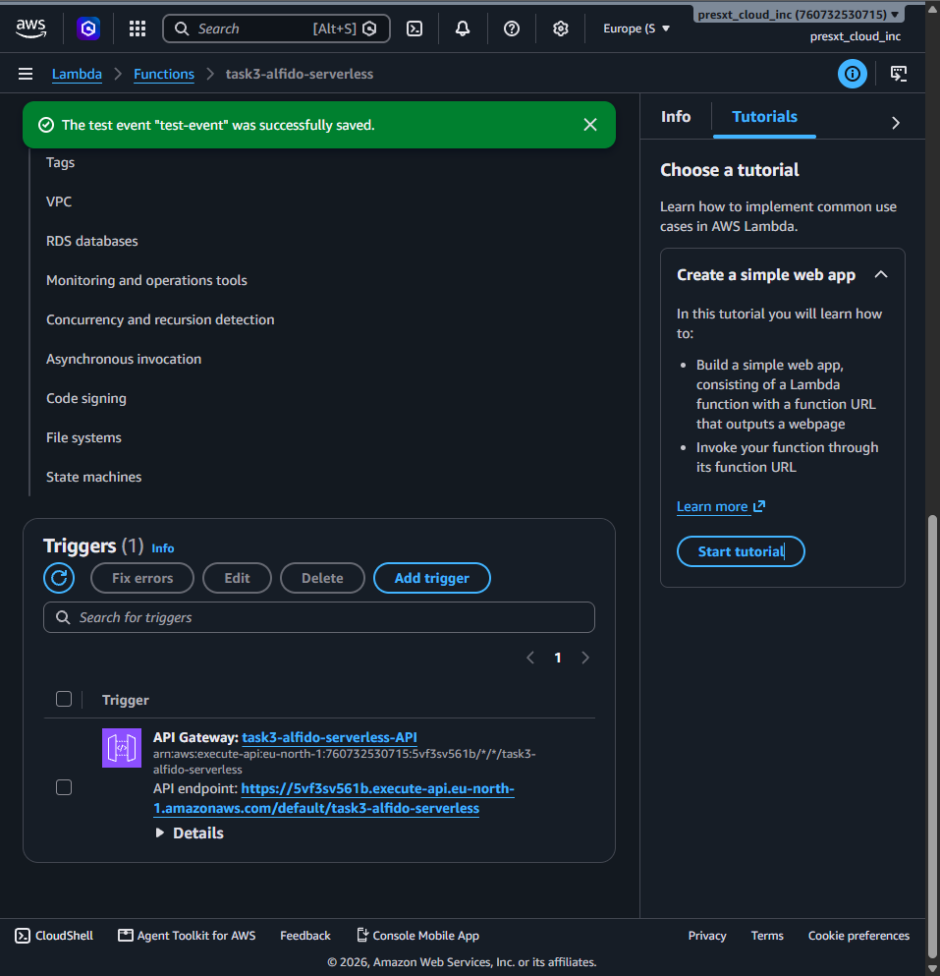
Fig 4.8.3(e): API Gateway trigger details showing the generated public API endpoint

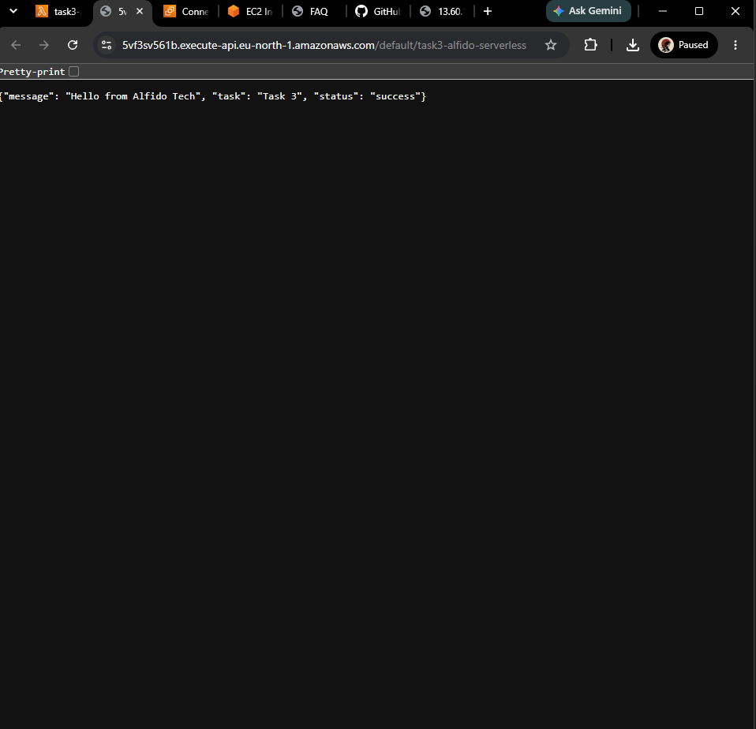
Fig 4.8.3(f): Public API endpoint opened in a browser, returning the expected JSON response

Result: The serverless function was successfully created, tested, deployed, and exposed through a public API Gateway endpoint that returns JSON output.
4.8.4 Task 4: Deploy a Docker Container on Cloud VM
Objective: To deploy a Docker container on an AWS cloud virtual machine and make the containerized web application publicly accessible.
Tools Used: AWS EC2, Ubuntu Server, Docker, Nginx.
VM Name: task4-alfido-docker
Operating System: Ubuntu Server
Container Image: Nginx
Container Name: alfido-nginx
Port: 80
Public IP: 13.60.81.133
Website URL: http://13.60.81.133/
Procedure:
- Created a separate Ubuntu Server virtual machine using AWS EC2.
- Configured the security group to allow SSH traffic on port 22 and HTTP traffic on port 80.
- Connected to the cloud VM using EC2 Instance Connect.
- Updated the Ubuntu package repository.
- Installed Docker on the virtual machine.
- Enabled and started the Docker service.
- Verified the Docker installation.
- Pulled and ran an Nginx Docker container.
- Mapped the container port 80 to the VM port 80.
- Verified that the Nginx container was running using docker ps.
- Accessed the containerized webpage using the VM public IPv4 address.
- Verified that the “Welcome to nginx!” webpage was publicly accessible.
Docker Commands Used:
sudo apt update
sudo apt install docker.io -y
sudo systemctl enable --now docker
sudo docker --version
sudo docker run -d --name alfido-nginx -p 80:80 nginx
sudo docker ps
Screenshots / Evidence:
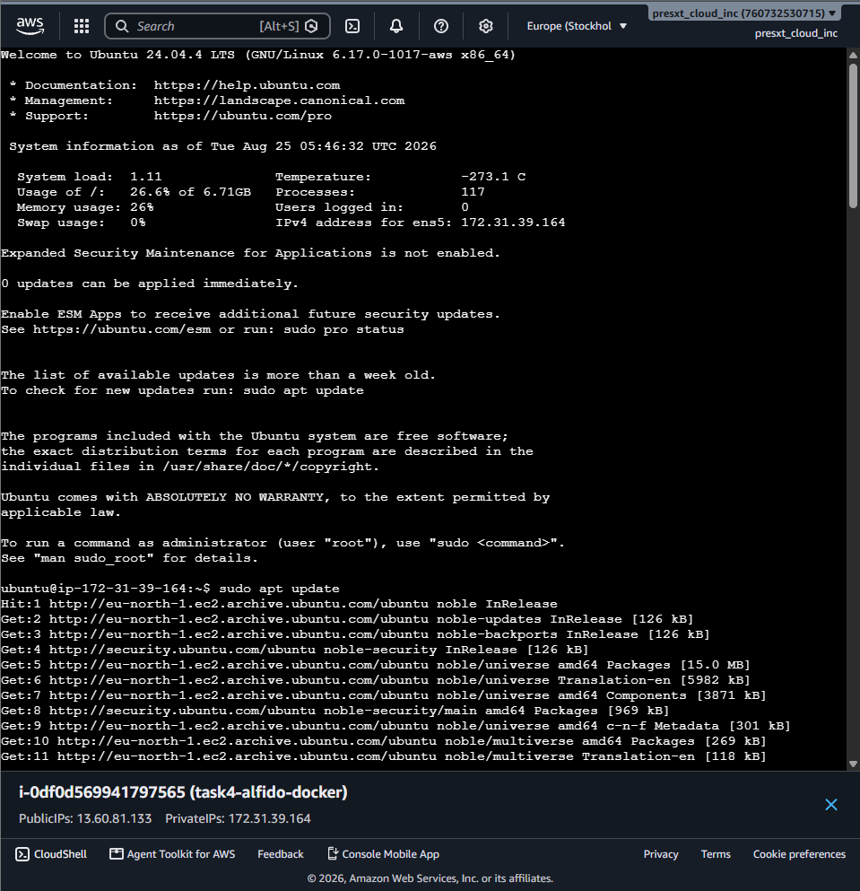
Fig 4.8.4(a): Connecting to the “task4-alfido-docker” EC2 instance and updating the Ubuntu package list

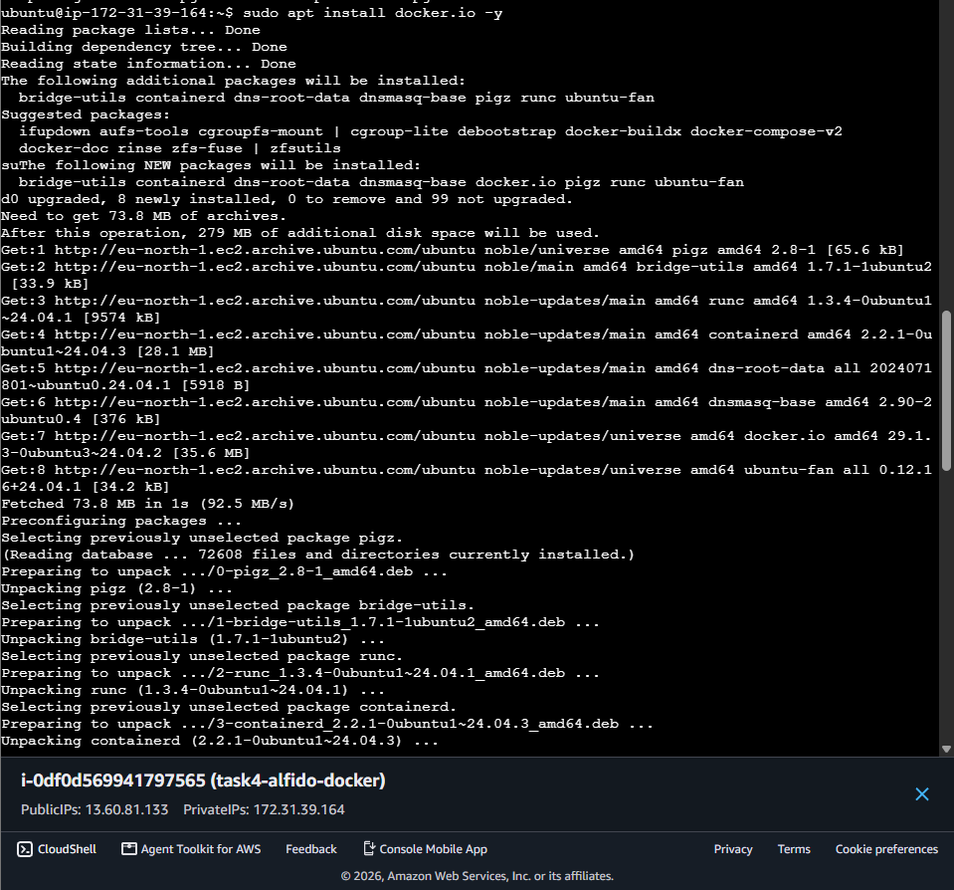
Fig 4.8.4(b): Installing Docker (docker.io) on the Ubuntu Server virtual machine

Result: The Docker container was successfully deployed on an AWS EC2 cloud VM. The Nginx container was running successfully, and its webpage was accessed publicly through the VM public IP address.
4.9 Expected Outcomes
- A publicly accessible static website hosted entirely on Amazon S3, without the need for a traditional web server.
- A cloud-hosted Ubuntu virtual machine running Apache2, serving a custom webpage over HTTP on port 80.
- A working serverless function on AWS Lambda that can be invoked over the internet through an API Gateway endpoint and returns a structured JSON response.
- A Docker container (Nginx) running on a cloud virtual machine, with its web page accessible publicly through the VM IP address.
- Practical, hands-on familiarity with core AWS services (S3, EC2, Lambda, API Gateway), Linux server administration, and containerization using Docker.
4.10 Certificates of Completion and Other Communication/Mail Proof
The following evidence is attached as part of the internship documentation.
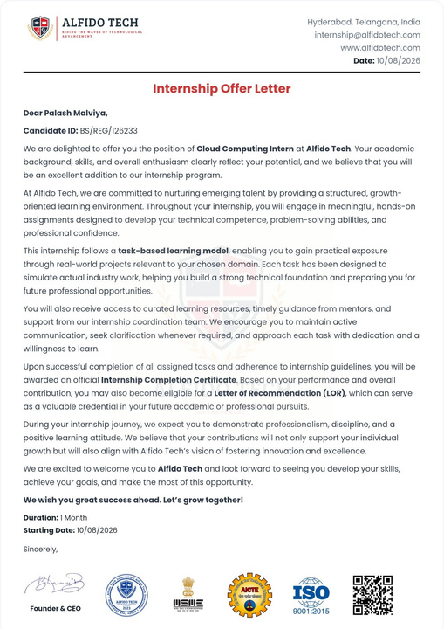
Fig 4.10.1: Internship Offer Letter issued by Alfido Tech (Candidate ID: BS/REG/126233, dated 10/08/2026)

5. BIBLIOGRAPHY / REFERENCES
[1] Amazon Web Services, “Amazon S3 - Static website hosting,” AWS Documentation.
[2] Amazon Web Services, “Amazon EC2 User Guide,” AWS Documentation.
[3] Amazon Web Services, “AWS Lambda Developer Guide,” AWS Documentation.
[4] Amazon Web Services, “Amazon API Gateway Developer Guide,” AWS Documentation.
[5] Docker Inc., “Docker Documentation.”
[6] The Apache Software Foundation, “Apache HTTP Server Documentation.”
[7] Canonical Ltd., “Ubuntu Server Documentation.”
[8] Alfido Tech, Cloud Computing Internship - Task 1 to Task 4 completion documents (internal internship material), 2026.

